

-GHULAM ISHAQ KHAN INSTITUTE OF ENGINEERING SCIENCES AND TECHNOLOGY
FACULTY OF COMPUTER SCIENCE AND ENGINEERING-----
Title: AutoShip – Automated Code Review & Deployment Dashboard
SE202L – Software Engineering Lab

Submitted By
- Muhammad Ahmad Faisal (2024335)
- Muhammad Haider Ali (2024385)
- Muhammad Zaid (2024491)

1. Project Overview ........................................................................................................................ 3
2. System Architecture ..................................................................................................................... 3
3. Technology Stack ....................................................................................................................... 4
4. Implementation Phases ............................................................................................................... 4
5. Code Submission & Team Contributions ................................................................................. 5

1. Project Overview
AutoShip is a sophisticated, containerized web application designed to implement a fully automated DevOps pipeline. Utilizing a FastAPI backend and a Jinja2 frontend, the application delivers a comprehensive dashboard for automated code quality analysis, including linting and cyclomatic complexity checking.

The primary objective of this initiative was to move beyond theoretical concepts and achieve mastery in the practical application of modern Continuous Integration and Continuous Deployment (CI/CD) methodologies. The resulting pipeline leverages Git for robust version control, Docker for streamlined containerization, GitHub Actions for CI/CD automation, AWS EC2 for stable cloud hosting.

2. System Architecture

The system architecture is engineered around a standard Continuous Deployment (CD) model, meticulously designed to ensure operational stability. This model guarantees that every successful code merge into the main branch triggers an automatic testing, containerization, and deployment sequence to a live production environment, achieving near-zero downtime. (Below is the system architecture diagram)

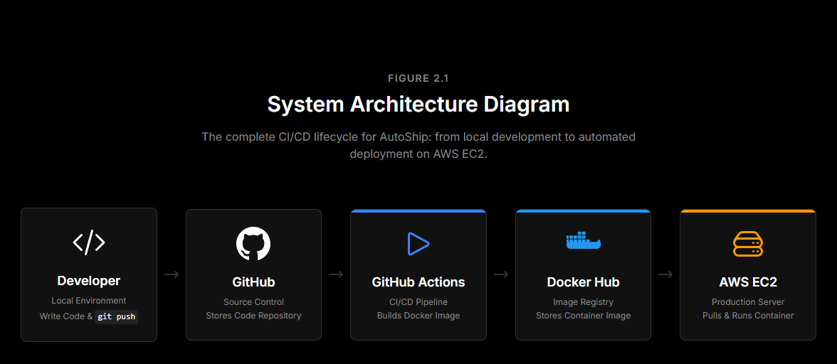
- 1. Version Control: Code changes are initiated and pushed to the GitHub repository.
- 2. Continuous Integration (CI): GitHub Actions automatically detects the push event, checks out the repository code, and executes the build process to create a new Docker image.
- 3. Container Registry: The validated, newly built image is securely pushed to Docker Hub.
- 4. Continuous Deployment (CD): GitHub Actions utilizes SSH to securely connect to the designated AWS EC2 instance, pull the latest image from Docker Hub, and orchestrate the service restart with the updated container.
-----Page 43. Technology Stack

The following technologies were strategically selected to ensure optimal performance, scalability, and adherence to industry best practices:
- Backend Services: Python 3.11, FastAPI (for high-performance API delivery), and Uvicorn (ASGI server).
- Frontend Presentation: HTML, CSS, and Jinja2 Templates for mirroring a modern, clean dashboard aesthetic.
- Data Persistence: SQLite database managed via the SQLAlchemy ORM for local data persistence of review histories.
- Code Quality & Analysis: Pylint (for static code analysis) and Radon (for cyclomatic complexity metrics).
- DevOps & Cloud Ecosystem: Docker and Docker Compose for container orchestration, GitHub Actions for pipeline automation, AWS EC2 (Ubuntu) for cloud hosting.
4. Implementation Phases

The project was successfully executed through a structured, five-phase implementation methodology. This approach allowed for clear distribution of responsibilities, ensuring robust and comprehensive coverage of the entire DevOps lifecycle.
Phase 1: Application Development
- Developed a Python-based FastAPI backend to manage routing and integration with the code analysis libraries.
- Created a Jinja2 template-based user interface, adhering to modern, clean dashboard aesthetics.
- Implemented SQLite for local data persistence, specifically to store historical code review metrics.
Phase 2: Containerization
- Drafted a Dockerfile utilizing a lightweight python:3.11-slim base image to optimize the final container footprint.
- Created a docker-compose.yml file to orchestrate the web service and manage necessary volume mounts for persistence.
- Verified isolated local execution and confirmed database persistence across container restarts.
Phase 3: Continuous Integration/Continuous Deployment (CI/CD) Pipeline Setup
- Configured repository secrets securely within GitHub for required Docker Hub and AWS credentials.
- Authored the .github/workflows/deploy.yml workflow to fully automate the build-and-push process as shown below:
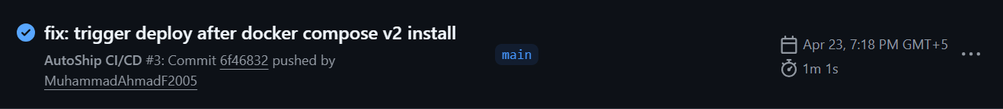

Phase 4: Cloud Infrastructure Deployment
- Provisioned an AWS Ubuntu t2.micro instance.
- Configured AWS Security Groups to expose port 8000 for primary web traffic and port 22 for secure SSH access.
[FIGURE 4.3: LIVE APPLICATION VIEW]
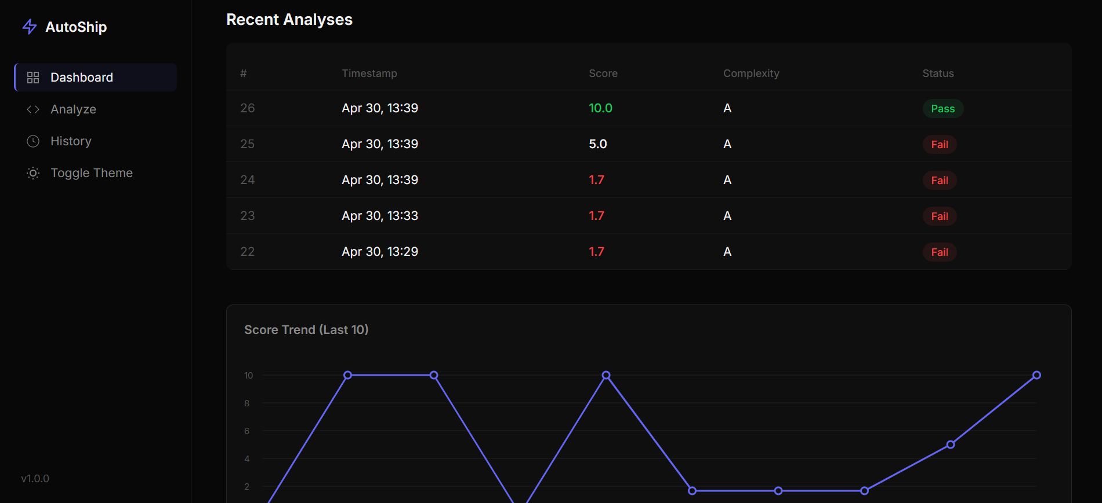

Repository Access: https://github.com/MuhammadAhmadF2005/AutoShip
repo access

In alignment with modern agile practices, the team prioritized collaboration by rigorously utilizing feature branching, pull requests, and distributed commits. This commitment allowed each member to assume critical responsibilities, ensuring expertise across all facets of the DevOps stack:
- Muhammad Ahmad Faisal: Spearheaded core FastAPI application development, driving the Dockerization process, establishing the GitHub Actions CI/CD pipeline configuration, and overseeing AWS EC2 deployment.
- Muhammad Haider Ali: Focused on ensuring project maintainability through comprehensive repository documentation (README.md, CONTRIBUTING.md), rigorous local testing, and environmental setup configuration.
- Muhammad Zaid: Managed the critical Infrastructure as Code domain, authoring the necessary yaml scripts for the robust provisioning of cloud resources and security groups. rigorous local testing, and environmental setup configuration. Oversaw AWS EC2 deployment and configuration of workflow along with formatting in report and documentation.

[FIGURE 5.1: GITHUB COMMIT HISTORY]
